13th October 2017

**YOKOHAMA wins prestigious marketing award**

* YOKOHAMA wins NTDA Marketing Campaign of the Year Award 2017
* Recognised for its successful tyre safety awareness campaign in partnership with Chelsea FC and TyreSafe
* Award win coincides with the 100th anniversary of the global Japanese brand

Premium tyre manufacturer YOKOHAMA has secured another major industry accolade having been awarded the NTDA Marketing Campaign of the Year Award 2017.

For its award-winning campaign, YOKOHAMA utilised its partnership with Chelsea Football Club to generate high-profile awareness of tyre safety issues, creating a powerful call to action encouraging football fans to check their tyres and travel safely.

The campaign strategy, which included events at Stamford Bridge Stadium and Chelsea FC’s training ground, incorporated digital marketing and social media activity across a number of platforms, successfully reaching thousands of motorists in the UK.

The award was presented to James Brown, marketing manager, Yokohama HPT Ltd at the NTDA’s annual award ceremony, which was held at Double Tree by Hilton at Stadium MK and hosted by BBC sports broadcaster John Inverdale.

Speaking at the ceremony James said, “It really is an honour to receive the prestigious Marketing Campaign of the Year Award, however this would not have been possible without the fantastic support and involvement from Chelsea FC, who have now become TyreSafe supporters in their own right. Every week, hundreds of thousands of football fans jump in their cars and travel around the UK to support their teams and we are proud to have played an important role in helping promote tyre safety issues and ensure they arrive safely.”

YOKOHAMA’s win follows a number of other significant accolades for the business in recent months. Earlier this year it was also named as TyreSafe’s Tyre Manufacturer of the Year for the second year running in recognition of its efforts in raising awareness about tyre safety.

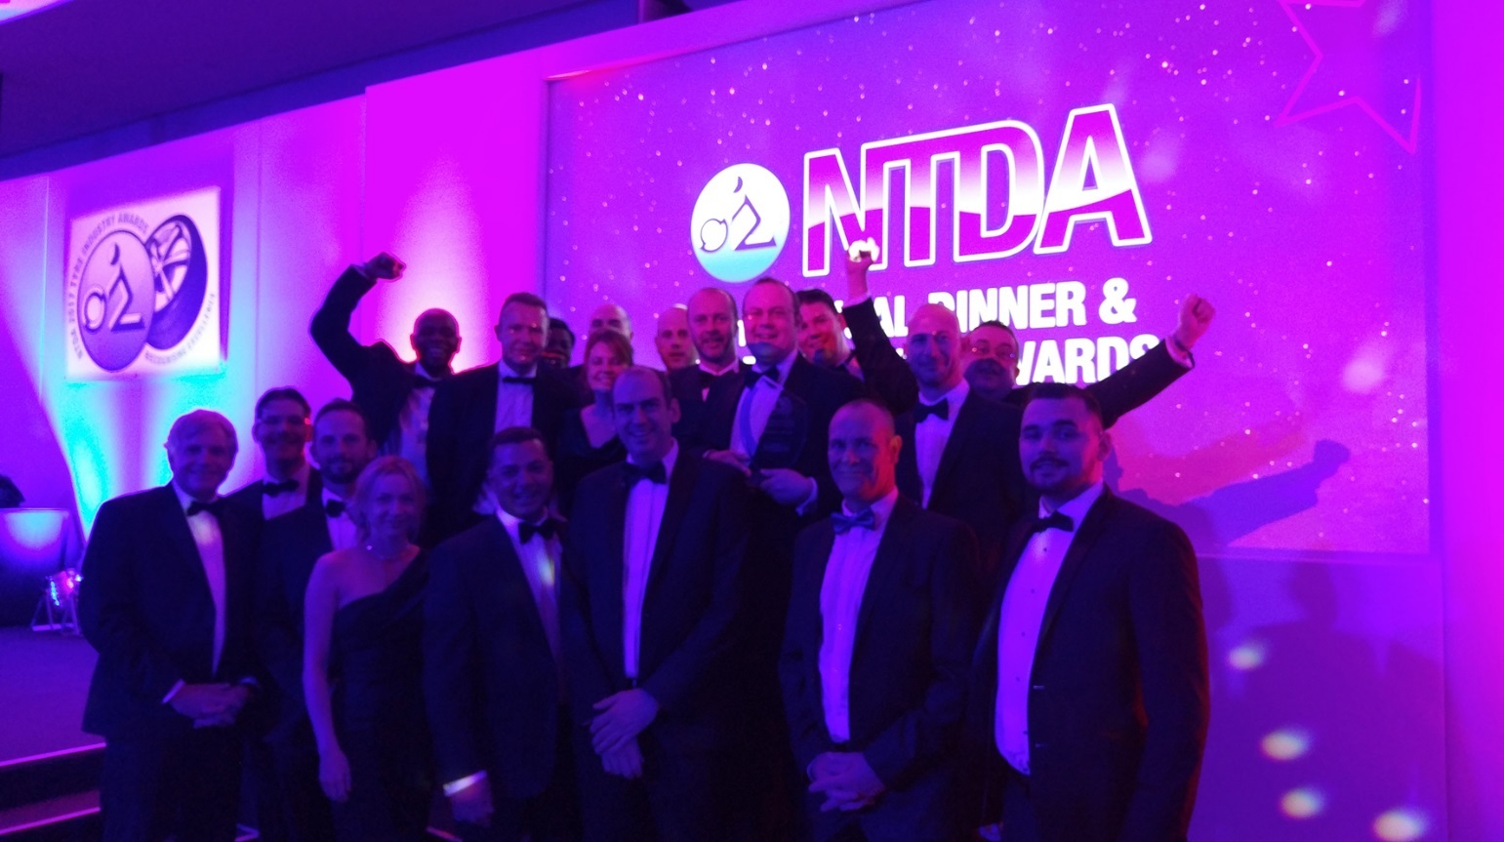

*YOKOHAMA has won the NTDA’s 2017 Marketing Campaign of the Year award*

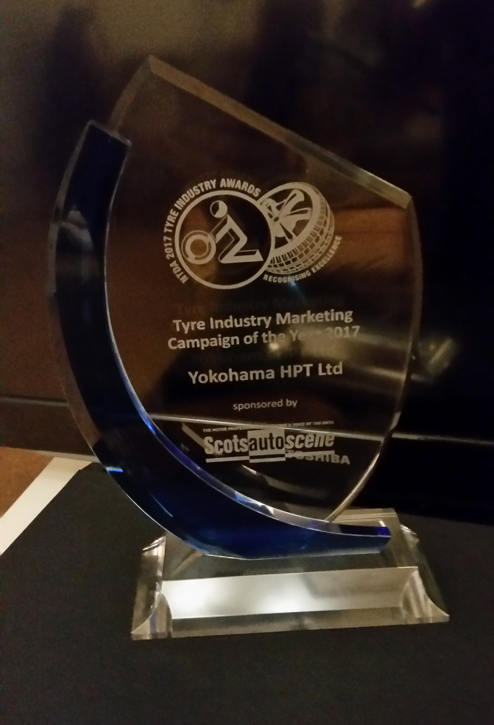

*YOKOHAMA NTDA Award 2017*